**One Credit**

**Salary_dataset :**

**Code :**

1.import numpy as np

import pandas as pd

2. dataset = pd.read_csv("Salary_dataset.csv") # first we need upload the dataset

dataset.head() # will shoe first 5 rows

3. x = dataset.iloc[:,0:1]

y = dataset.iloc[:,1]

x.head()

y.head()

4. from sklearn.model_selection import train_test_split

x_train,x_test,y_train,y_test =

train_test_split(x,y,train_size=0.8,random_state=42)

5. from sklearn.linear_model import LinearRegression

model = LinearRegression()

6. model.fit(x_train,y_train)

7. samplepredciton = model.predict([[1240]])

print(samplepredciton)

y_pred = model.predict(x_test) # predicting for all x_test

y_pred

y_test

y_pred

list(zip(y_test,y_pred))

8. import numpy as np # Hypothetical housing dataset

areas = np.array([1000, 1030, 1060, 1090])  # House areas in square feet

prices = np.array([5618, 5201, 4779, 5245])  # House prices in dollars

# Example of a simple linear regression model (hypothetical coefficients)

m = 200  # slope

b = 50000  # intercept

# Make predictions

predicted_prices = m * areas + b

# Calculate squared differences

squared_diff = (prices - predicted_prices) ** 2

# Calculate mean squared error

mse = np.mean(squared_diff)

print("Actual Prices:", prices)

print("Predicted Prices:", predicted_prices)

print("Squared Differences:", squared_diff)

print("Mean Squared Error:", mse)

9.from sklearn.metrics import r2_score

r2 = r2_score(y_test, y_pred)

print(f'R-squared score: {r2:.2f}')

y_test

**ScreenShots:** 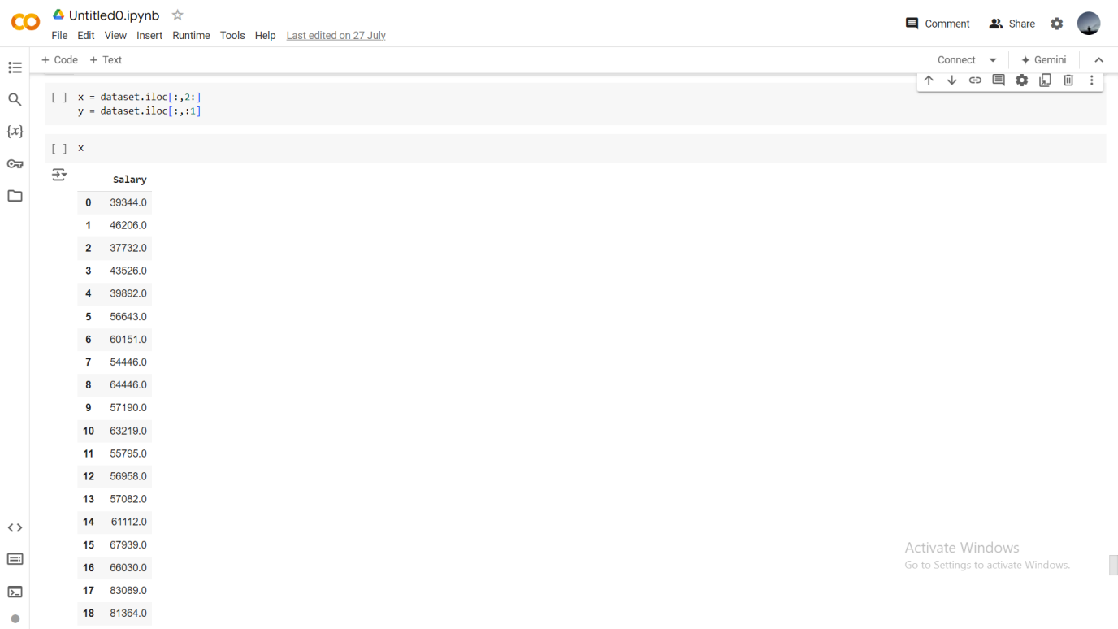

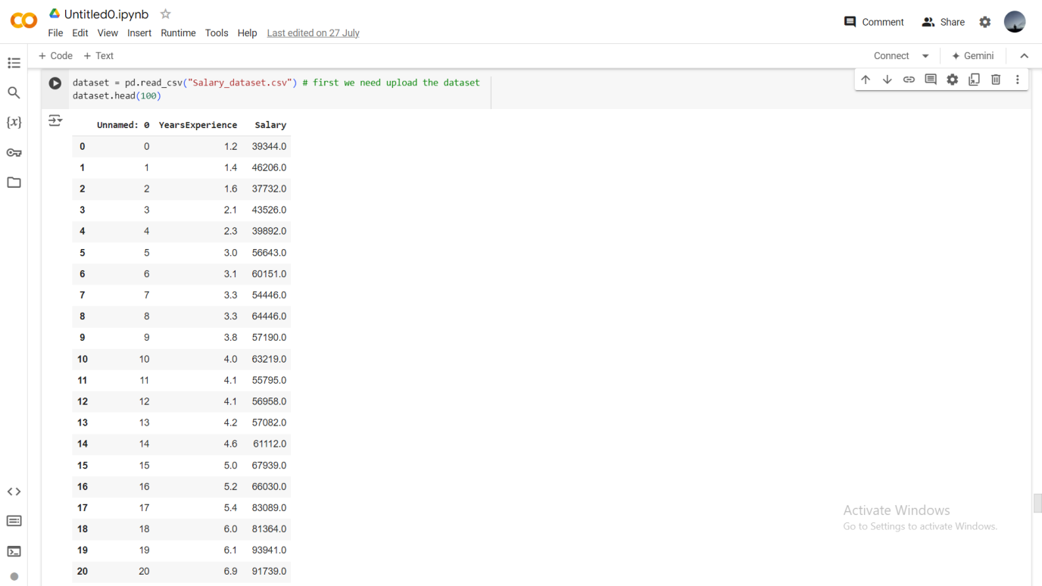

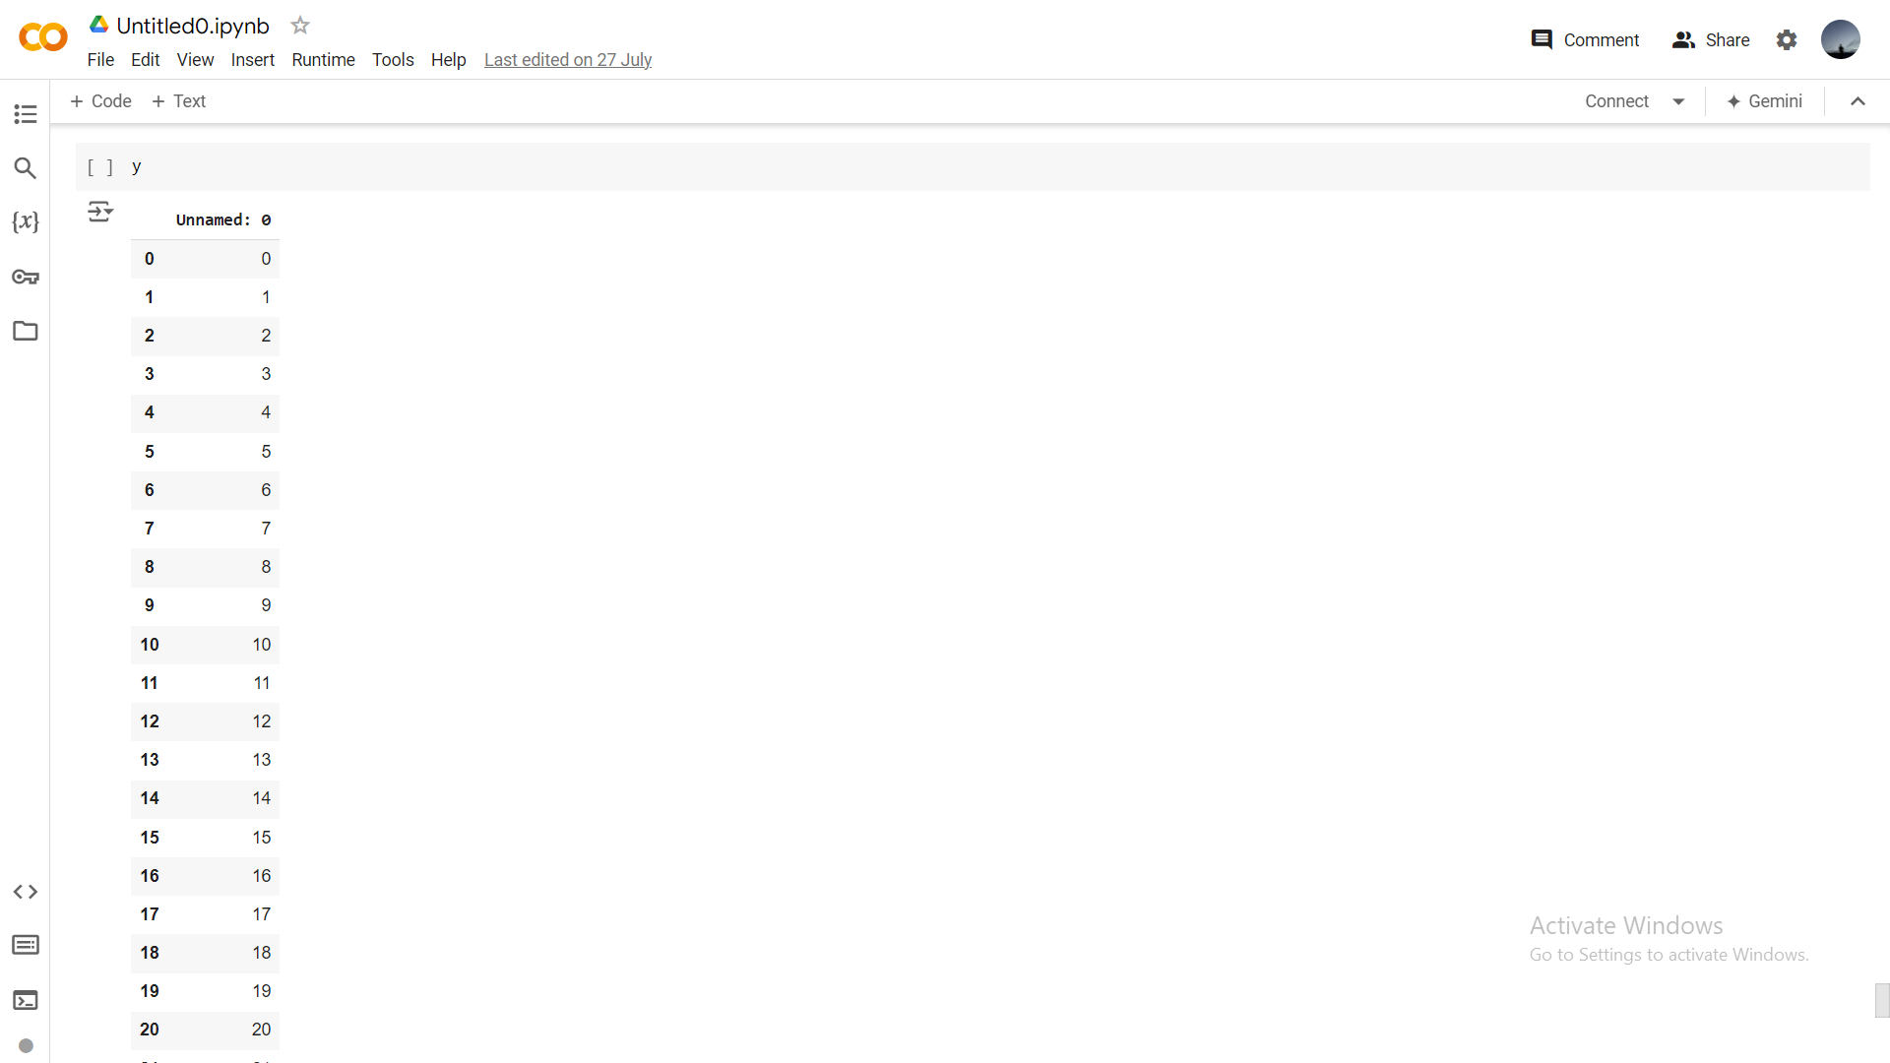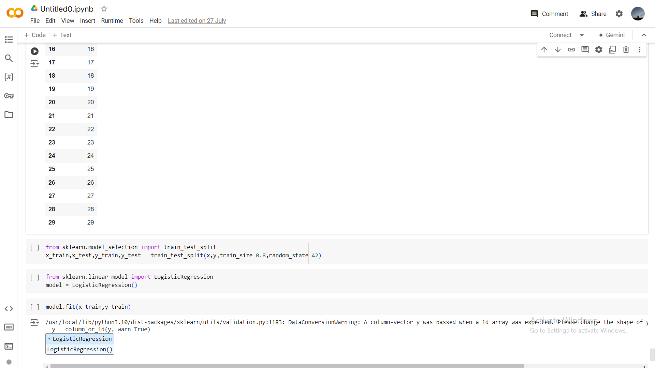

**Penguins_binary_classification:**

**Code :**

1.import numpy as np

import pandas as pd

2. dataset = pd.read_csv("penguins_binary_classification.csv") # first we need upload the dataset

dataset.head() # will shoe first 5 rows

3. x = dataset.iloc[:,0:1]

y = dataset.iloc[:,1]

x.head()

y.head()

4. from sklearn.model_selection import train_test_split

x_train,x_test,y_train,y_test =

train_test_split(x,y,train_size=0.8,random_state=42)

5. from sklearn.linear_model import LinearRegression

model = LinearRegression()

6. model.fit(x_train,y_train)

7. samplepredciton = model.predict([[1240]])

print(samplepredciton)

y_pred = model.predict(x_test) # predicting for all x_test

y_pred

y_test

y_pred

list(zip(y_test,y_pred))

8. import numpy as np # Hypothetical housing dataset

areas = np.array([1000, 1030, 1060, 1090])  # House areas in square feet

prices = np.array([5618, 5201, 4779, 5245])  # House prices in dollars

# Example of a simple linear regression model (hypothetical coefficients)

m = 200  # slope

b = 50000  # intercept

# Make predictions

predicted_prices = m * areas + b

# Calculate squared differences

squared_diff = (prices - predicted_prices) ** 2

# Calculate mean squared error

mse = np.mean(squared_diff)

print("Actual Prices:", prices)

print("Predicted Prices:", predicted_prices)

print("Squared Differences:", squared_diff)

print("Mean Squared Error:", mse)

9.from sklearn.metrics import r2_score

r2 = r2_score(y_test, y_pred)

print(f'R-squared score: {r2:.2f}')

y_test

**ScreenShots:** 

